**What are the Key differences between JavaScript and HTML? Examples of situations where you would use each?**

|  |  |
| --- | --- |
| **HTML** | **JAVA Script** |
| 1. HTML is Markup Language | 1. JS is a client side scripting language. |
| 2. HTML defines the structure of webpage | 2. JS defines the behaviour of web page. |
| 3. HTML is not case sensitive | 3. JS is case sensitive |
| 4. HTML runs on client side | 4. JS runs on Client side and server side |
| 5. HTML defines the content of the web page | 5. JS allows for manipulation of content |
| 6. HTML files are saved with .html extension | 6. JS files are saved .js extension. |

**Example for file saving extension**

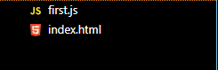

**Structure & Behavior of web page**

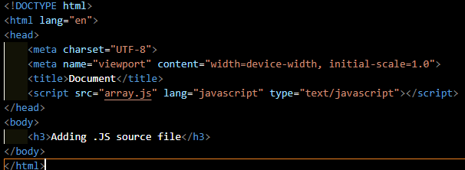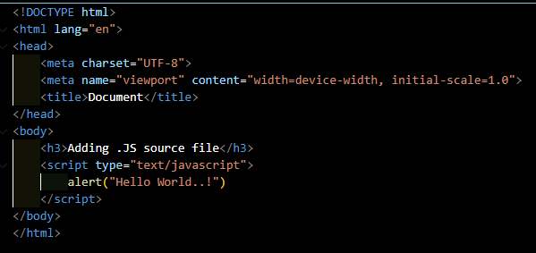

Displaying structure JS is displaying alerts on web page